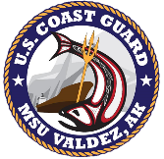
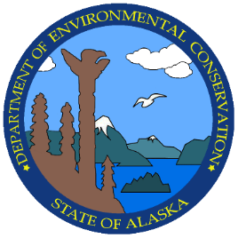
Prince William Sound Area Committee Meeting
October 14th, 2025
Virtual (MS Teams)

INTRODUCTIONS
0900
Introductions and opening remarks
PWS AC Secretaries, Lt Bradley Ragan, USCG and Julie Liford-Parker, DEC
FOSC Commander Sarah Rousseau
SOSC Anna Carey
Attendees

guest Presentations
0915
DEC/USCG/EPA – Statutes and Authorities – Chief DeAngelo, Petty Officer Hanson, FOSCR
PWS Area Plan Updates, Julie Liford-Parker
Exercises in Prince William Sound
2025 Polar Tankers Shippers Exercise, May 2025
Petro Star Valdez Petroleum Terminal, September 2025
Valdez Marine Terminal, October 2025
2026 Fairwater Valdez Shippers Exercise, May 2026

0945
PWS RCAC project, Copper River Delta GRS, Mike Donnellan, DEC

1015
Break

1030
Port of Valdez, AJ Keeton – Harbor responsibilities and capabilities

1050
Resolve Marine, Zack Verfaillie – Salvage

1110 - 1145
Case review:
Montague Island pollution debris, USCG
Petro Star Valdez Refinery, Mo Radotich, DEC
Mineral Creek, Sonya Mishmash, DEC

1145 - 1200
Public comment and closing remarks

